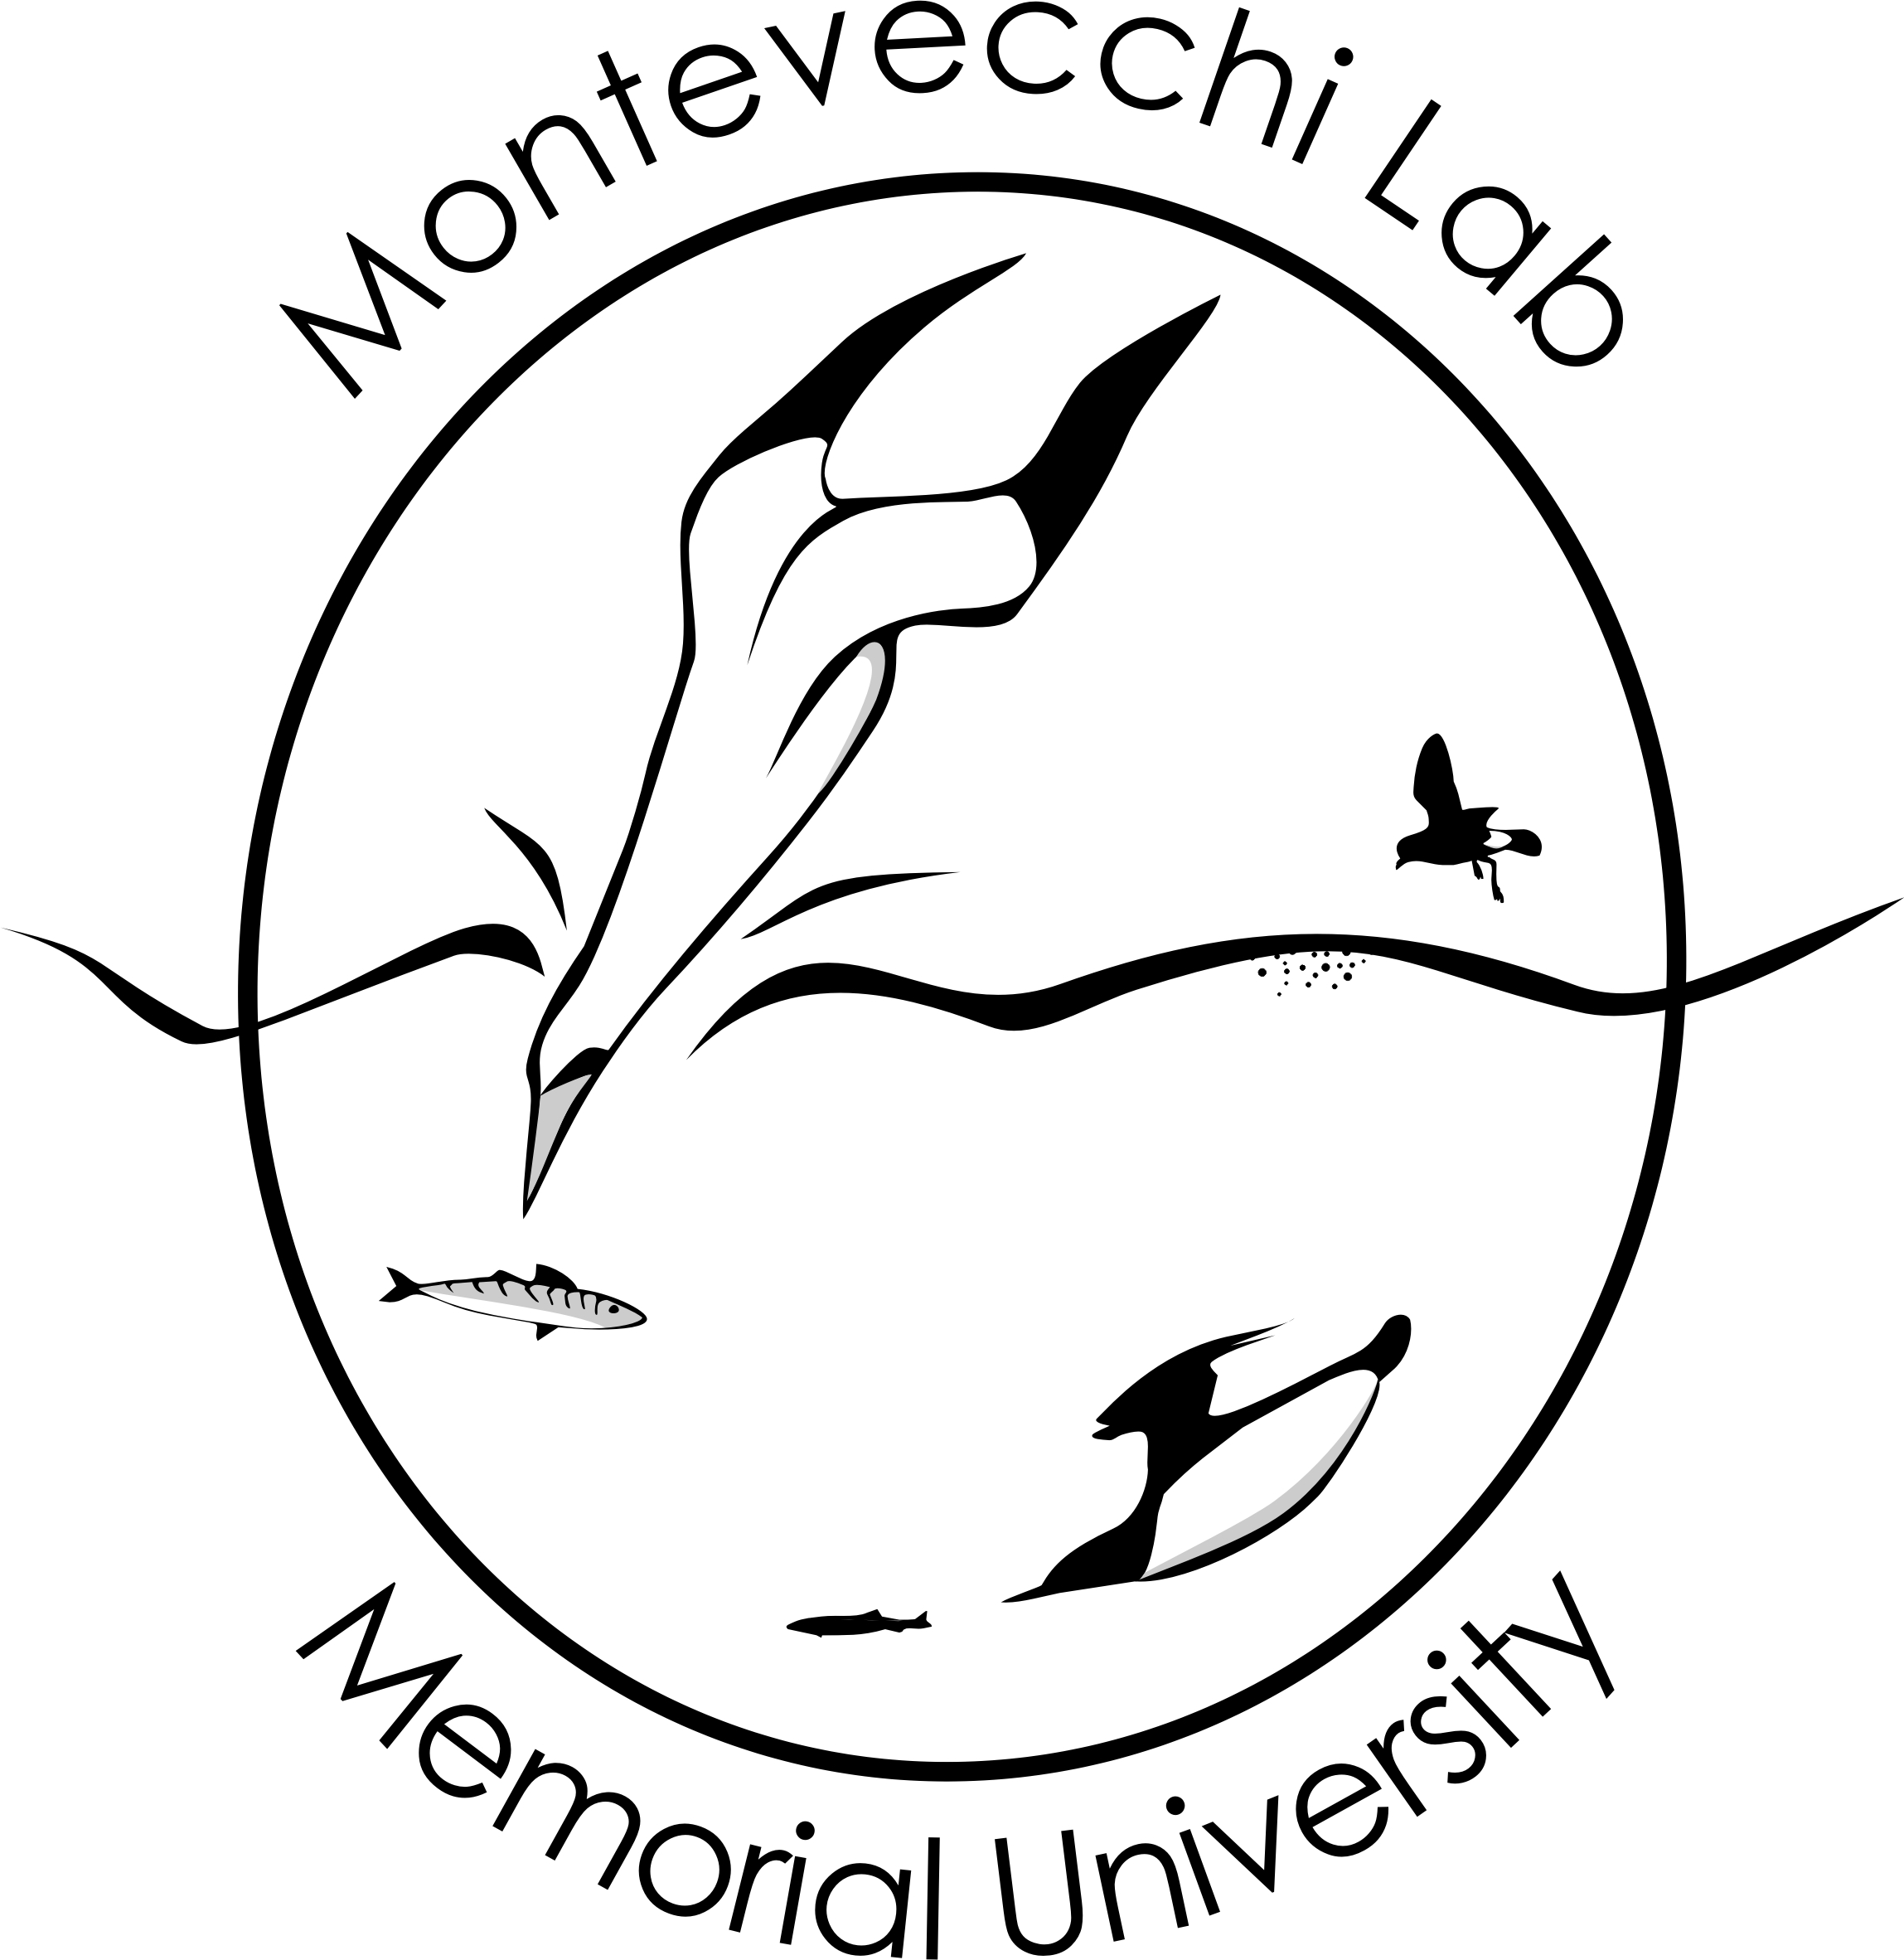

15 January 2024

Dear Editor Brigham:

Please accept for review the attached manuscript – “Geographic, ecological, and temporal patterns of seabird mortality during the 2022 HPAI H5N1 outbreak on the island of Newfoundland”. This manuscript has been developed from Gretchen McPhail’s B.Sc. Honours Thesis (Biology, Memorial University of Newfoundland and Labrador; April 2023).

Owing to the devastation that HPAI (Highly Pathogenic Avian Influenza) H5N1 inflicted on seabirds throughout the North Atlantic Ocean, including eastern Canada, during 2022, the research attracted a number of federal researchers also investigating the virus to collaborate with our research.

Our manuscript documents the mortality of seabirds on the island of Newfoundland, showing that Northern Gannets and Common Murres were the most highly impacted species. We also detail the temporal and spatial movement of the observations of mortalities from April through September 2022 and west to eastward along the Newfoundland coast and by the major seabird colonies in the western Atlantic. Exploratory hypotheses based on seabird ecology and behavior highlighted associations of species mortality with nesting density, timing of breeding, and at-sea overlap with allo-specifics from other colonies.

The data in this paper are a subset of the data previously submitted by Avery-Gomm et al. to Ecospheres (bioRxiv preprint: https://doi.org/10.1101/2024.01.05.574233). Our paper differs by examining detailed and important regional trends and associations with species ecology. All co-authors concur with this submission.

Thank you for you attention.

W. A. Montevecchi
Professor Emeritus
John Lewis Paton Distinguished University Professor

cc: G. M. McPhail
C. M. Collins

